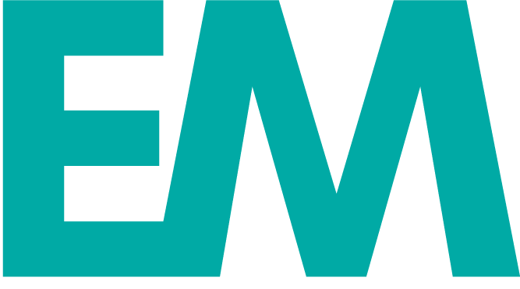
Emily McTavish

(715) 456-9869
em.mctavish@gmail.com
www.emilymctavish.com
Twitter: @EmMcT

NEWS PRODUCER
KRDO NEWSCHANNEL 13 - COLORADO SPRINGS
July 2019 to Present
- Produces full hour 4 p.m. broadcast using ENPS to stack show and write stories with snappy teases
- Coordinates reporter coverage and pitches ideas for breaking and spot news
- Creates original graphics, both still and video, for broadcast
- Brought 6 a.m. hour of Good Morning Colorado to the top-rated spot in D.M.A.
- Created new style guide ahead of 2020 election

NEWS PRODUCER
GOOD DAY DePAUL - DePAUL UNIVERSITY, CHICAGO
September 2018 to May 2019
- Winner: College Student Production Newscast Category, Chicago/Midwest Chapter of the National Academy of Television Arts & Sciences
- Produced weekly show covering campus, local and national news
- Shot and edited video and created original, animated graphics for broadcast
- Secured exclusive interview with Alderman Ed Burke on 2019 municipal election

COMMUNICATIONS ASSISTANT
DePAUL UNIVERSITY COLLEGE OF LAW - CHICAGO
September 2017 to June 2019
- Managed official social media channels for College of Law
- Took photos at College of Law events and headshots of new faculty
- Designed advertising pieces for print trade publications
- Wrote feature articles on notable students and alumni for website

METRO INTERN
CHICAGO SUN-TIMES - CHICAGO
September 2018 to November 2018
- Produced an exclusive multi-platform piece on a community center in jeopardy of being demolished
- Assisted with 2018 midterm election coverage, including the Illinois attorney general’s race
- Contributed to the Illinois Bicentennial special Sunday insert featuring more than 200 businesses

DePAUL UNIVERSITY, CLASS OF 2019
Master’s of Arts in Journalism with an emphasis in multimedia
Master’s Student of the Year for Journalism

MISSOURI STATE UNIVERSITY, CLASS OF 2016
Bachelor’s of Science in Journalism, Magna Cum Laude

